Bank Churn Data Mining

# Customer Locations

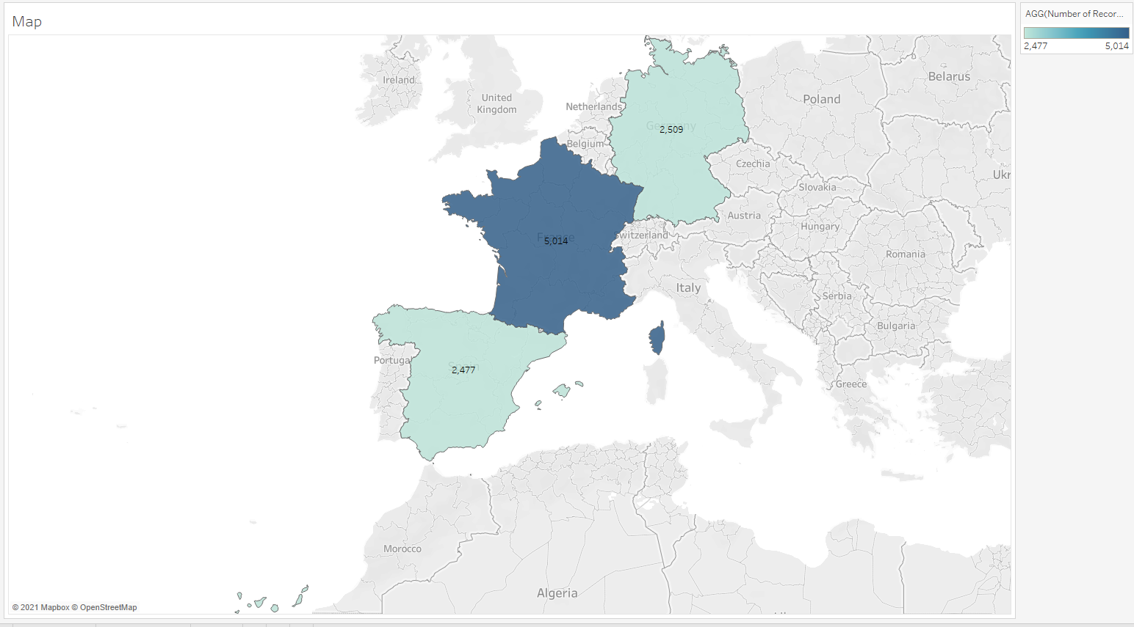

# AB Comparison of Gender on Churn

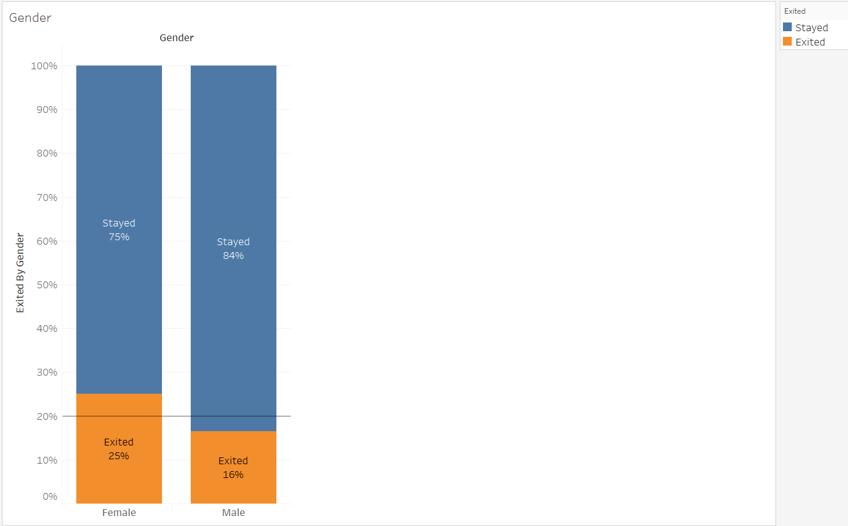

# ABC Comparison of Location on Churn

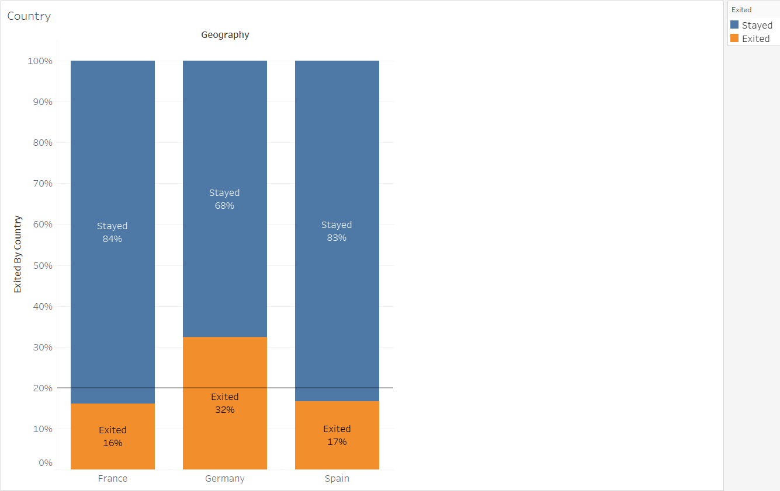

# AB Comparison of whether Customer has a Bank Credit Card on Churn

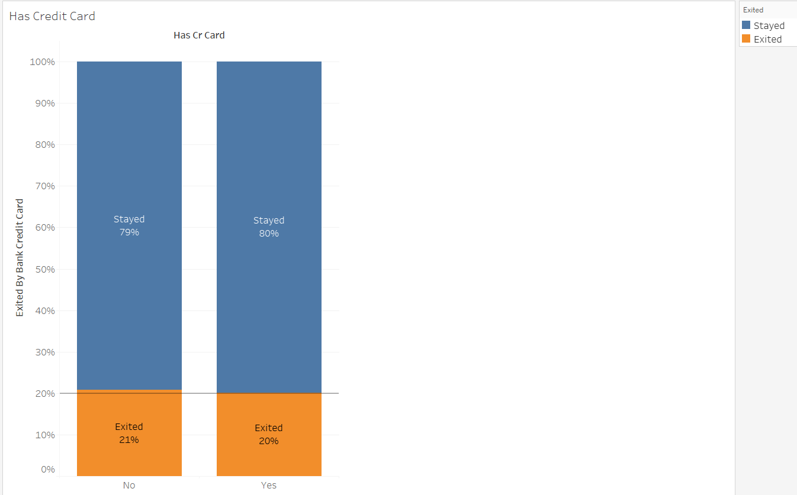

# AB Comparison of whether Customer is active at Bank on Churn

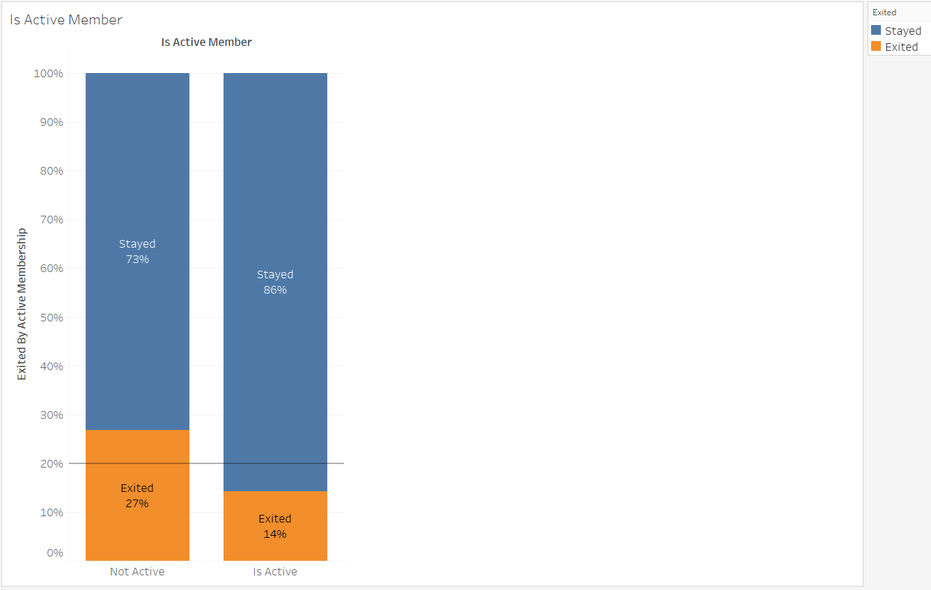

# ABCD Comparison of Number of Bank Products on Churn

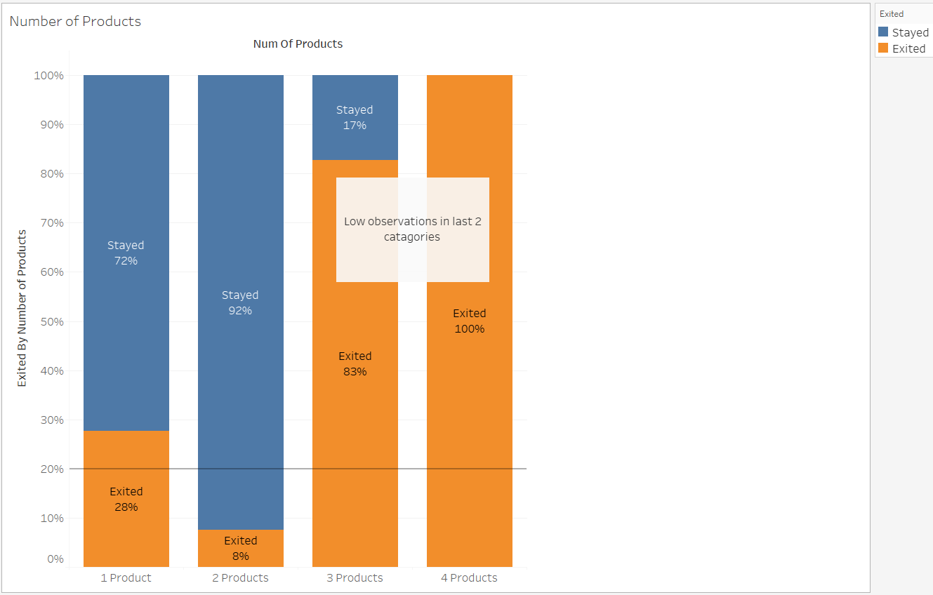

# Validations

